
2015 FRANCHISE CONFERENCE
CEO Notebook
For: _______________




Thanks!

Thanks for attending my session of CEO Boot Camp at the conference. This notebook is available online at www.CEOBootCamp.com/honeybaked in both Word and PDF format. Feel free to download them and print as many pages as you need.

How to Use This CEO Notebook
- Set aside weekly CEO time. Make sure you keep your appointments with yourself.
- Go someplace comfortable, away from the store. Maybe at home, maybe at a coffee shop.
- Do not be disturbed. Turn off your phone, don’t check email.
- Be sure to review your notebook every week.

Yearly Plan
Once a year, copy a new Yearly Plan Page and fill in one or two critical things you need to get done each month.
Look at a real calendar so you know when the holidays are since Easter and Thanksgiving may come early some years and late other years. And some months have 5 weekends or an extra payroll.

Monthly Plan
At the start of the month review the previous month’s plan. How did you do?
- Copy a new Monthly Plan Page, write down your focus for that month (from the Yearly Plan)
- Write how will you execute it week by week. If anything needs to be carried over from the previous month, write it in as well.
- Be sure to check your numbers - finances and your inventory.

Hiring
Use these charts to help define who you’re looking for and keep in touch with people you may want to hire.

Marketing
Use the M.A.P. to schedule when you’ll do your marketing pushes and when you’ll use each of the tools available to you. Use the “big spender” chart to keep track of potential customers who come to mind as you meet people or have CEO time.

Thoughts & Observations
Use this page to record anything you want to follow up on – goals and accomplishments, problems or things that need fixing, or anything else that the quiet of CEO time brings to mind.

Annual Calendar
What is the most important thing to do each month?
January | February
March | April
May | June
July | August
September | October
November | December

Monthly Calendar Month of: _________________________________________________________
What are the key things this month (from my yearly plan)?
1. ________________________________________________________________________________________

2. ________________________________________________________________________________________

Week 1
Week 2
Week 3
Week 4

Money
Cash in Bank at start of month __________________ Estimate of Cash at end of month __________________
Actual Cash at end of month ___________________ Explain the difference between estimate and actual.

Inventory
Date I last took inventory __________________
What did I learn? _______________________________________________

Employees

Position:_________________________________

Traits | Skills / Experience

People I might want to hire:

Name | Phone | Email | How we met

Marketing Action Plan – MAP
FSI | Bulk Emails | Personal Emails | Special Offers
Post Cards | POS Stands | Ads | Social Media
Direct Mail | Phone Calls | Coupons

When will you use the marketing tools you have available?
January | February
March | April
May | June
July | August
September | October
November | December

Marketing to Big Spenders
WHO - Name | HOW – phone / email / address | WHEN - Times I reached out | WHAT  C= Catering G=Gift B= Both

Numbers

What are the key numbers that matter to you?
How do they change over time?

Key Metric | This Month | Last Month | Same Month a year ago

Thoughts & Observations

More Resources
Thanks for attending,
John Seiffer, Business Advisor
If I can be of any help at all, feel free to email me with questions at John@CEOBootCamp.com. Plesase check out the free articles on my website and the opportunity to subscribe to my newsletter. Visit www.CEOBootCamp.com
Also you may enjoy some of the eBooks below. They are very short, practical reads. You can print them out, or view them on any computer, tablet or phone. They’re just $5 each – visit https://gumroad.com/ceobootcamp

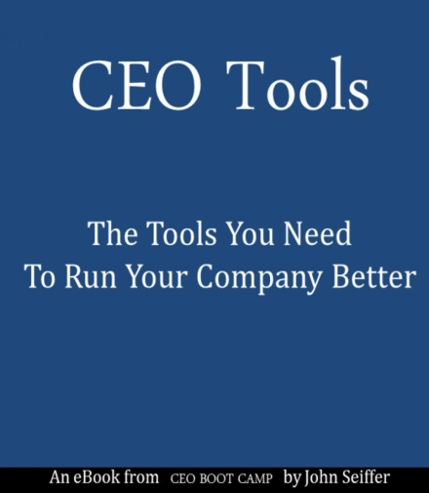 | Learn tools that other CEOs are using to help them grow their companies faster. Simple to apply in any size firm for faster growth.  Tool #1 - Leadership. There's a science as well as an art to being a better leader. It's easy to learn.  Tool #2 - Delegation. Poor delegation skills are a key reason people get frustrated growing a company. But that doesn't need to happen - this is a tool that anyone can apply.  Tool #3 - War Room. This is a tool that helps everyone make decisions with the most up to date information.  Plus a very powerful insight about the distinction between a function and a job. You'll have to read the book to learn what it is.
 | How to Grow Your Business & Keep Your Head on Straight  An overview of the different things every company needs to pay attention to in order to grow. Learn how to organize all the aspects of your growing business, so you can stay focused and run your business better.
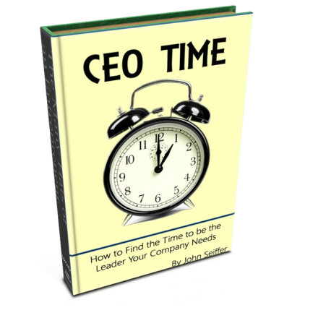 | Time is our most precious commodity. Learn how to use your time most effectively as CEO. This is not a time management book! I know you perform other functions in your company - not just CEO. This eBook is a way to make sure you're maximizing your CEO time.

